Auction Point.com

|  |  |  |  |
| --- | --- | --- | --- |
| *S.no* |  | *Student ID* | *Student Name* |
| 1 |  | Student1445433 | Raja Tahir |

**Project Advisor**

Miss. Nimra Mughal



Website Name: **Auction Point.com**

**Main Pages in Website:**

1. Home
2. About Us
3. Contact Us
4. Shop
5. Blog

**Technology am i using:**

1. HTML 5
2. CSS 3
3. Bootstrap 5 (Framework of CSS)
4. JavaScript
5. JQuery
6. Font Awesome

**ACKNOWLEDGEMENT**

First of all we would like to thank ALLAH the almighty who make us able to complete this project.

After that we would like to express profound gratitude to our internal project advisor, Center Senior Faculty, ***Engr. Nazish Sattar***, for her precious support, back-up, supervision and useful suggestions throughout this project. Her moral support and continuous help enabled us to complete our work successfully. We are also highly thankful to the ***Center Management*** for their valuable suggestions, healthy analysis and support throughout this project.

We are grateful to the faculty members of Aptech Korangi Center who were always there to help us despite of their personal workload.

We are as ever, especially indebted to our parents for their love and support throughout our life. We also wish to thank our classmates, friends and all the individuals or groups that were involved in this project by any mean.

**Requirements of Projects:**

1. Home page with suitable logo.
2. A menu which will include all the functions implemented in the site.

3. The site should provide the information about following Auction Point:

a. Cars

Apart from the above mentioned Auction Point, you may add other Auction Point of your

choice.

4. The user should be able to search a particular Auction Point.

5.Provide a ‘About Us’ page which will introduce the company.

8. There should be a “Contact Us” page which will have the Address of the

Company and the mail address which when clicked will invoke the local mail

client from where they can send an email.

9. The site should have appropriate look and feel suitable to company’s

reputation and status.

**HEADER****

**FOOTER**

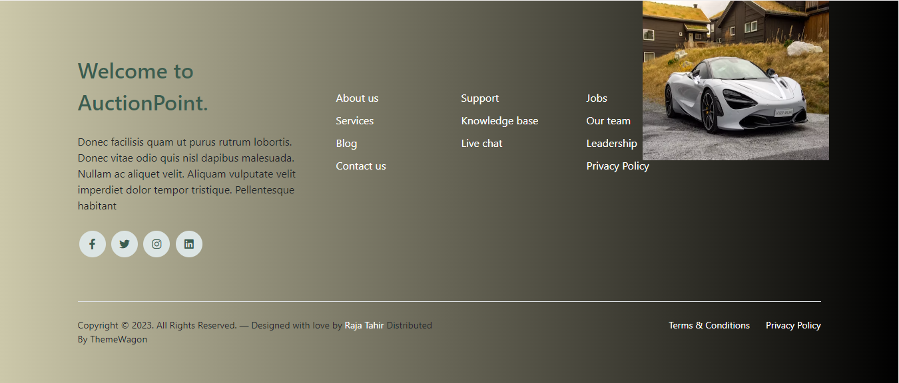

**HOME PAGE**

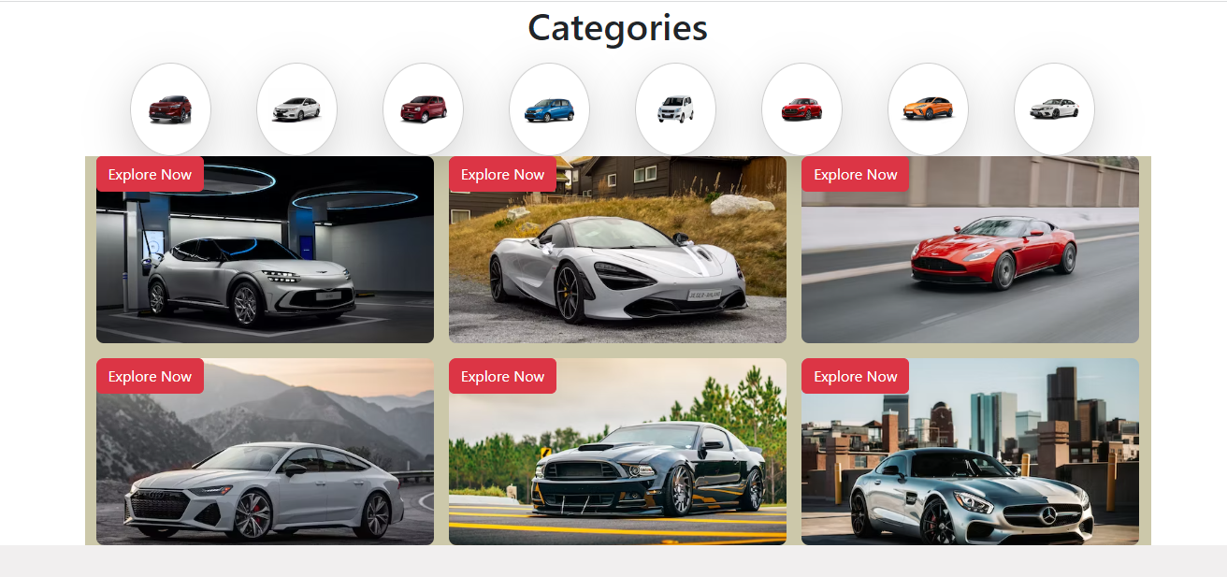

**CAROUSEL**

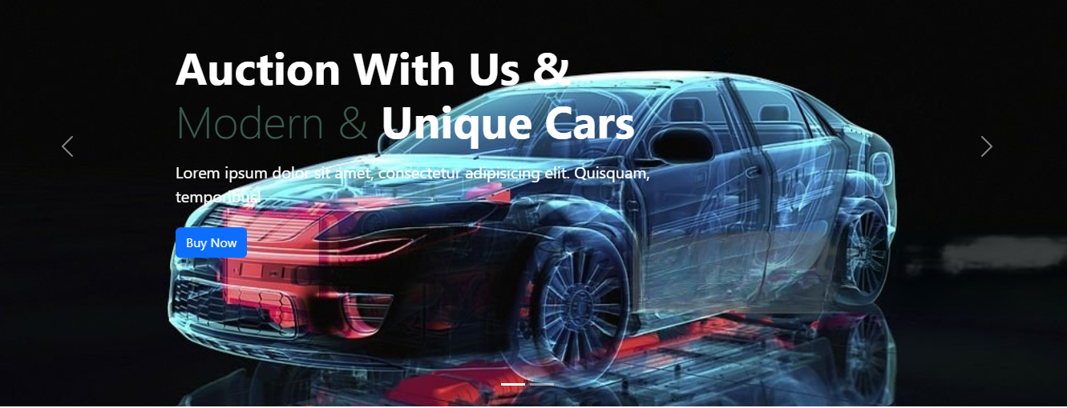

**CARS DETAIL**

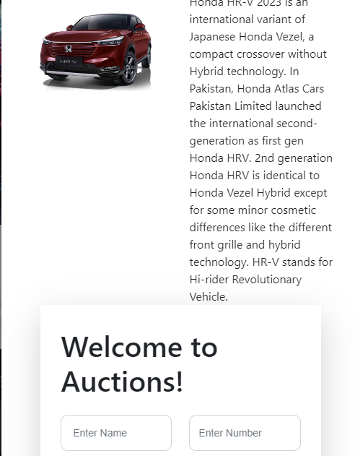

**Blog Page.**

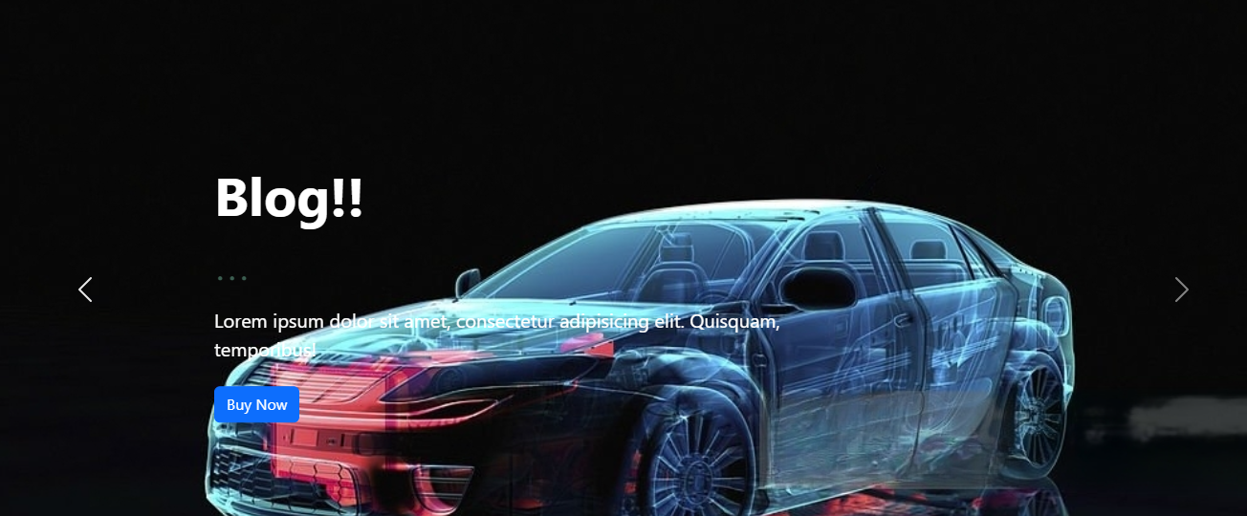

**ABOUT US PAGE**

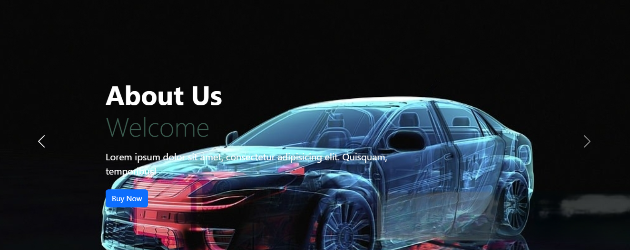

**Shop Page.**

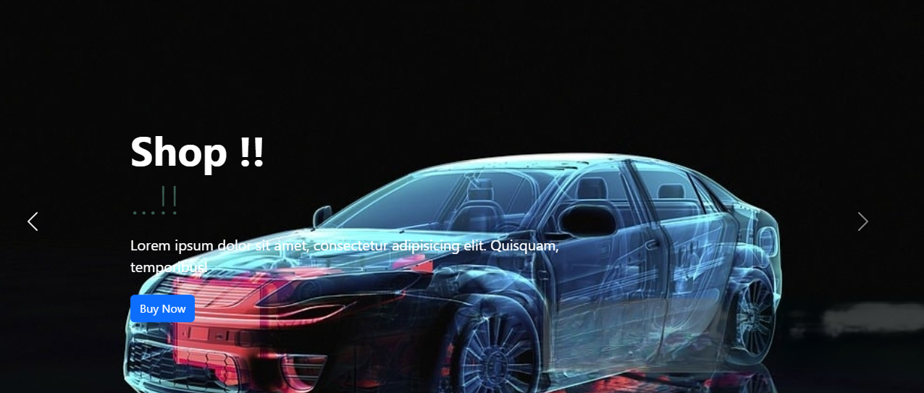

**CONTACT US PAGE**

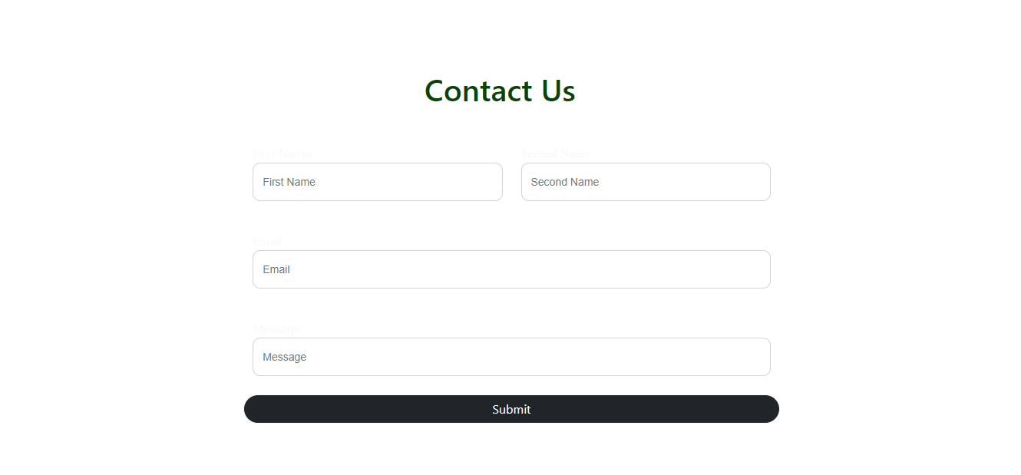

1. 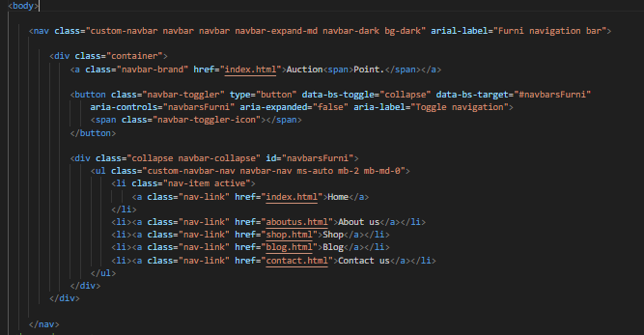**Header & Navbar Coding**
2. 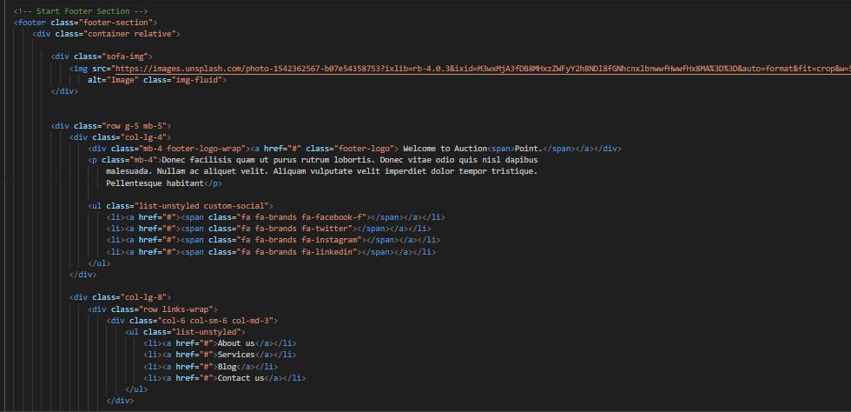**Footer Coding**
3. 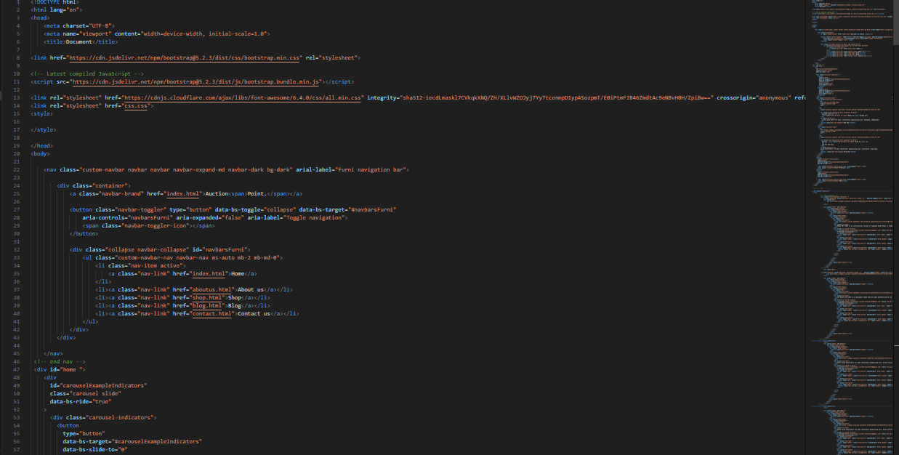**Home Page Codding**
4. **About Us Page Coding**

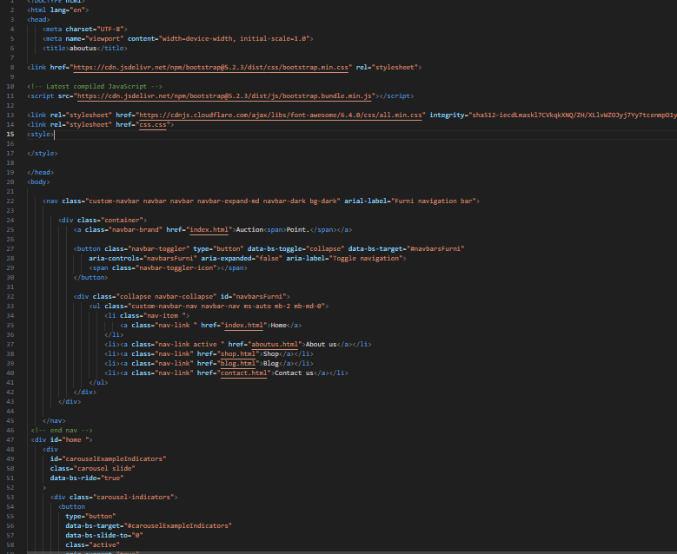

1. **Contact Us Page Coding**

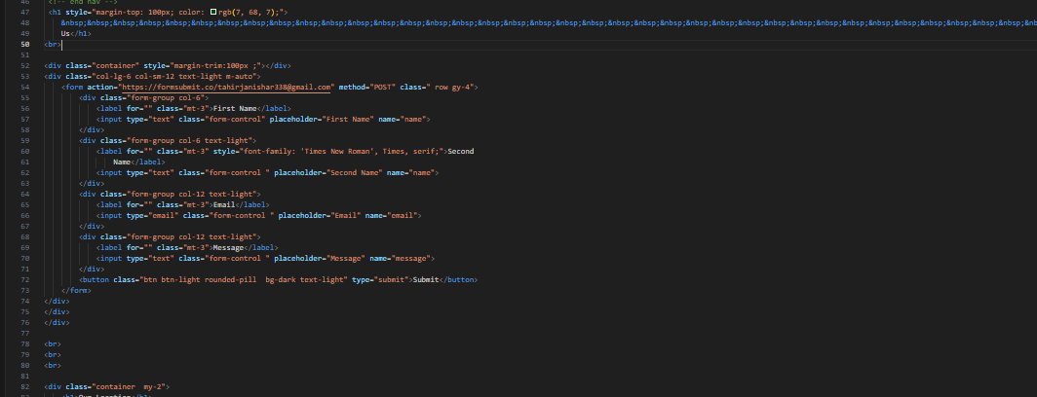

**FIRST SEMESTER PROJECT**

**Auction Point**

